WPS Canteen Menu - 2025

Sandwiches

 | Sandwich
Plain – butter only | $1.00
Vegemite | $2.00
Egg or Salad base | $3.00
Ham or Cheese base | $3.50
EXTRAS
Cheese - $1
Lettuce, tomato, grated carrot, beetroot - 50c each
Tomato sauce - 30c Mayonnaise – 60c

Toasties
One Filling $4.00
Cheese or ham
Two Fillings $5.00
Ham with Cheese;
Cheese or Ham with Tomato
Three Fillings $5.50
Ham with Cheese & Tomato

Snacks some available over-the-counter only
UFO, frozen pineapple ring .50c
Frozen 1/21 Banana popsicle .50c
Popcorn .50c
Apple Slinkys $1.00
Chocolate Cookies .50c
Muffin, mini .50c
Muffin, regular $1.00
Assorted Chips (Red Rock 28g) $2.30

Ice Cold Refreshments available over-the-counter only
Various including
Bulla Yoghurt Minis, Quelch Juice Icy Tubes, Juice Pops, Paddle Pops From $1 to $3

Drinks
Water, 600ml $2.00
Flavoured Milk, 200ml $3.20
Strawberry or chocolate

Juice, 100% juice, 250ml $2.20 Orange, Apple
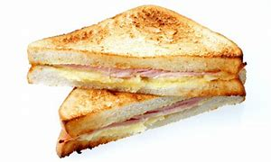

Salad Box

Egg or Cheese salad box *GF $5.50
Ham salad box $6.50
with optional lettuce, tomato, carrot, beetroot

Hot Food
Condiments:
Tomato sauce 30c
Mayonnaise 60c
Cheese $1.00

Corn Cobs $1.50

Wedges $3.50
Extras- sweet chilli sauce 50c
sour cream each $1.00

Hotdog $5.20
with optional sauce or cheese additional cost

Chicken Burger- 2 Chicken tenders base $6.00
Fish Finger Burger- 3 Fish Fingers base $4.50
with optional
Lettuce, sliced tomato, grated carrot, 50c
tomato sauce 30c
mayo 60c
Cheese $1

Chicken Tenders - 2 per serve $5.00

Fish Fingers – 5 per serve $5.00

Pizza Home Made/Freshly Made
Create your own pizza $6.70
Choose toppings from tomato, cheese, pineapple, capsicum, onion, ham,

Warm Ham & Cheese Roll $5.20

Pasta

Cheesy Macaroni Bake $4.30
Pasta with Napoli sauce optional cheese 50c $3.70

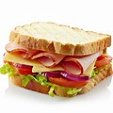
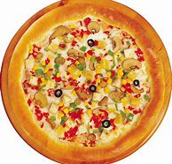


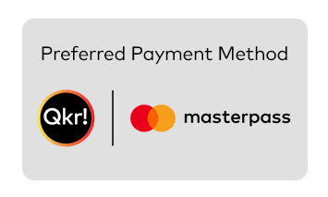

ORDERING YOUR LUNCH

TO ORDER RECESS OR LUNCH...:

• Place order via Qkr app by 9:00am or place lunch bags in the class lunch order box by 9:00am
• Lunch orders received after 11.00 am will comprise of a vegemite or buttered sandwich.
NOTES...
• If a child does not receive all of his/her lunch order they should go to the canteen on the day with their lunch order bag so it can be organised
• Children who have no lunch at school will be supplied with a basic sandwich of vegemite at $2.00 or Cheese at $3.50
• Children who go home sick should let the canteen know via their teacher if they have a lunch order so that it can be cancelled where possible
• The Governing Council reserves the right to alter prices
LUNCH BAGS...
• Please order lunch using a PAPER LUNCH BAG or via the Qkr App - NO plastic or envelopes
• Lunch bags are sold from the canteen, minimum purchase 4 bags for 30 cents.

CANTEEN OVER THE COUNTER TIMES Tuesday to Friday - CLOSED ON MONDAYS
Recess: 10.30am - 11.00 am
Lunch: 1.00pm -1.15pm
The Canteen Manager is in attendance from 8.30 am to 2.00 pm
PARENT/CARER HELPERS...
• Our canteen is able to be maintained because of the generous help from our parent and carer volunteers
• We require helpers at the canteen from 9:00am to 1:30pm Tuesday to Friday
- Please contact the front office if you would like to apply to volunteer
• Once rostered to volunteer please let the Front Office know if you are unable to attend on your rostered day
• In thanks, all parent helpers are entitled to a food item of their choice (subject to availability) as well as tea or coffee at no charge.
PARENT HELP IS ALWAYS APPRECIATED AND IS ESSENTIAL FOR THE EFFICIENT RUNNING OF THE CANTEEN WOODVILLE PRIMARY SCHOOL—Telephone 8445 2744

